“Quoting Characters”
Grades: 4-5
Subject | Language Arts
Overview | In this activity, students will read “Charlotte’s Web” and create flash cards to specify a character on one side and a quote said by that character on the other.
Standards | Students will understand the reading and acquire, assess and communicate information.
Materials  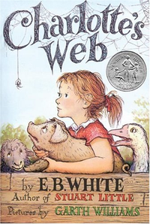 | - “Charlotte’s Web” by E.B. White  - Note cards  - Pencil or pen
Procedure | - Read the book “Charlotte’s Web” as a class.  - After finishing the book, students will identify at least five characters from the book.  - Students will write each character’s name on a note card  - Students will identify a quote that was said by each character and write that quote on the back of the note card with the character’s name on the front  - When finished, students will get into groups and take turns reading the quotes on the back of the note cards, and then guess which character said what quote
Objectives | Following this activity, students are able to:  - Identify main characters  - Connect quotes from the book to the characters
Evaluation | - Students have created note cards to identify main characters  - Students can refer to note cards before test over “Charlotte’s Web”

http://lessonplanspage.com/LAScienceArtCharlotteMainCharactersQuoting45.htm/

